Communication Requirements for
Legitimate Relationships

P1R2

Amendment History:

Version | Author | Date | Amendment History
0.1 | Peter Beresford | 24/11/03 | First draft
0.2 | Peter Beresford | 3/12/03 | Updated draft
0.3 | Peter Beresford | 19/12/03 | Updated draft
0.4 | Peter Beresford | 23/12/03 | Updated draft
0.5 | Peter Beresford | 21/1/04 | Updated draft
1.0 | Peter Beresford | 23/1/04 | Approved version distributed to ISPs
1.1 | Tom Parker/ Sarah Bagshaw / Kay Sandhu | 13/2/04 | Added updates from meeting held 26/1/04  Version to support message implementation pack.
2.0 |  | 5/3/04 | Approved version
2.1 | Sarah Bagshaw | 27/3/04 | Updated to reflect changes for P1R2 messages
2.2 | Incorporating changes from Malcolm Oswald and Tom Parker | 15/4/04 | Fixing errors and making minor changes due to evolution of design.
3.0 |  | 19/4/04 | Approved
3.1 | Sarah Bagshaw | 13/05/04 | Updates for MiMv3.1
3.2 | Tom Parker | 20/5/04 | Changes to split “LR confirm” messages, make minor corrections and add the consent override flag and reason code to the messages that need them.
3.3 | Sarah Bagshaw | 17/6/04 | Final for approval following agreement of changes with IG & BT.
4.0 |  | 24/06/04 | Approved
4.1 | Sarah Bagshaw | 28/07/04 | [Changes to support P2R1 – now incorporated into separate document]
4.2 | Sarah Bagshaw | 04/08/04 | Update following comments from IG team
4.3 | Sarah Bagshaw | 13/10/04 | Final changes to support MiM 3.1.07
4.4 | Sarah Bagshaw | 27/10/04 | Draft for approval

Approvals
This document requires the following approvals.

Name | Signature | Title | Date of Issue | Version
Max Jones |  | Programme Head | 22/6/04 | 3.3
Margaret Baldock |  | Programme Manager | 22/6/04 | 3.3
Max Jones |  | Programme Head | 24/06/04 | 4.0

Document Location
This document is only valid on the day it was printed. Please contact the Document Controller for location details or printing problems.

This is a controlled document. On receipt of a new version, please destroy all previous versions (unless a specified earlier version is in use throughout the project).
© Crown Copyright 2004

Unauthorised copying, distribution, renting, lending or communicating to the public of all or a substantial part of any Crown Copyright material is prohibited. Licences for the use of Crown Copyright material are available from Her Majesty's Stationery Office, at http://www.hmso.gov.uk (click on 'Click-Use licences').
All trade marks and logos are the property of their respective owners. The use of any trade mark or logo without the prior written permission of the relevant owner is prohibited.

Contents

1 Purpose 7
2 Create New Legitimate Relationship 8
2.1 Description 8
2.2 Clinical Scenario 8
2.3 Activity diagram 9
2.4 Business Transactions 9
2.4.1 Create Legitimate Relationship Request 9
2.4.2 Legitimate Relationship Creation Response 21
3 Legitimate Relationship Status Change 24
3.1 Description 24
3.2 Clinical Scenario 24
3.3 Activity diagram 25
3.4 Business Transactions 25
3.4.1 Legitimate Relationship Status Change Request 25
3.4.2 Legitimate Relationship Status Change Response 31
4 Legitimate Relationship Confirmation Request 35
4.1 Description 35
4.2 Clinical Scenario 35
4.3 Activity diagram 36
4.4 Business Transactions 36
4.4.1 Legitimate Relationship Confirmation Request 37
4.4.2 Legitimate Relationship Confirmation Short Response 44
4.4.3 Legitimate Relationship Confirmation History Response 46
5 Legitimate Relationship Batch Confirmation Request 49
5.1 Description 49
5.2 Clinical Scenario 50
5.3 Activity diagram 50
5.4 Business Transactions 50
5.4.1 Legitimate Relationship Batch Confirmation Request 51
5.4.2 Legitimate Relationship Batch Confirmation Response 57
6 Obtain Legitimate Relationship Details 61
6 Obtain Legitimate Relationship Details 61
6.1 Description 61
6.2 Clinical Scenario 61
6.3 Activity diagram 62
6.4 Business Transactions 62
6.4.1 Legitimate Relationship Record Details Request 62
6.4.2 Simple Legitimate Relationship Record Details Response 70
6.4.3 Complete Legitimate Relationship Record Details Response 75

Purpose

- This document describes in detail the message content of each of the business communications outlined in the Legitimate Relationships Detailed Business Analysis report. There shall be one W5 for each W3. Where there are many business processes, these shall be encompassed in separate sections of a single W5
- It forms the deliverable for each Work Stream Domain – Business Communication definition and refinement stage (W5) in accordance with the Communications & Messaging Programme Development methodology
- It lists the data items, their inter-relationships, grouping, data typing, validation rules and coding (where appropriate)
- It lists, at a data level, any issues that have been identified that would hinder development and/or implementation
- It provides a means to communicate the proposed message content to the Programme’s Technical (message development) team to enable them to form the required HL7 message constructs; and similarly to the suppliers that will have to build them

Extracts from W3 Detailed Business Analysis Document:

Issue: Legitimate Relationships are one component of the overall security mechanism of the national systems. The relationship between Legitimate Relationships, Role Profiles, Sealed Envelopes, etc., must be clearly understood, and defined in terms of an end-to-end business environment, to prevent gaps occurring in the business process, and to ensure that conflicts in functionality are not introduced into the individual component processes.

Assumption: Validation of the rights and privileges of the individual or application affecting Legitimate Relationships records, when performed by the managing application, will be performed as part of its normal functionality. These validation processes and associated messages are therefore not included in this document.

Create New Legitimate Relationship

Description
Whenever a need arises to set-up a Legitimate Relationship between a patient and a User Role Profile (NCRS User),Workgroup or Other Person, a record of the relationship is created on the appropriate national system. A request is generated, either by an individual user, or from an automated source (depending on business rules embedded in the system functionality), and a record of the relationship details is placed on the appropriate system database.

Assumption: For this document, the national systems are seen as a single entity, and no account is taken of any data transfer or communication across the national system component applications.

Clinical Scenario
To be determined, pending design of the end-to-end business processes.

Activity diagram
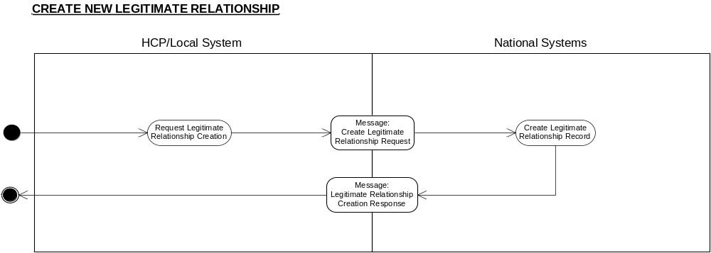

Business Transactions
- Create Legitimate Relationship Request
- Legitimate Relationship Creation Response

Create Legitimate Relationship Request

Purpose
The message is generated to notify the national system to establish a Legitimate Relationship record between the patient and the Workgroup, User Role Profile or other individual.

Business Communication Requirement

Communication Name | Create Legitimate Relationship Request
Sending Role | Request Legitimate Relationship Creation
Trigger Event | Legitimate Relationship creation required.
Communication Type | Request
Receiving Role | Create Legitimate Relationship Record

Business Communication Content

Level | Name  Item/Group | Definition | Example | Representation | Cardinality | Constraints & Dependencies | Default value | Null required | Outstanding issues
1 | Request Identifier | The unique identifier for the request message, generated by the system. |  | Format defined by Technical team:  UUID | 1
2 | Patient Identifier | The unique identifier for the patient involved in the Legitimate Relationship.  The identifier may be a temporary NHS Number, which would later be reconciled with the real NHS Number. | 1234567899 | NHS Number - Data Dictionary Standard  N10, including check digit calculated to Modulus 11 algorithm  OID 2.16.840.1.113883.2.1.4.1 | 1
3 | Start LRinvolved Group | Either a User Role Profile, Workgroup, or Other person is required. |  |  | 1..1 | This group contains one and only one of its possible subgroups
3.1 | Start Workgroup Details Subgroup |  |  |  | 0..1
3.1.1 | Workgroup Identifier | An identifier for a Workgroup. | 210987654321 | 12 character code - SDS representation | 1
 | End Workgroup Details Subgroup
3.2 | Start User details subgroup |  |  |  | 0..1 | NB if LR type is Colleague Granted or Self Claimed, choice of this group is mandatory as LR can only apply to an individual.
3.2.1 | User id | The SDS User identifier | 123456789012 | Twelve character UID as defined by the SDS group | 1 | If the LR type is self claimed, the User Id given here must be the same as the originating User Id in field 9.
3.2.2 | User Role Profile | The context in which the individual acts as part of the Legitimate Relationship. | 210987654321 | Twelve character UID as defined by the SDS group | 1
 | End User details subgroup
3.3 | Start Other Person subgroup |  |  |  | 0..1
3.3.1 | Other Person NHS Number | The unique identifier for the Other Person involved in the Legitimate Relationship. | 1234567899 | NHS Number Data Dictionary standard  N10, including check digit calculated to Modulus 11 algorithm | 1 | Not to be returned in P1R2. |  |  | Added as placeholder for possible future implementation.
 | End Other Person subgroup
 | End LR Involved Group
4 | Legitimate Relationship End Date and Time | The date and time at which the Legitimate Relationship will be considered frozen. |  | HL7 standard, accurate to ‘seconds’. | 0..1 | Must be later than Legitimate Relationship Start Date and Time. | Null |  | This field is not expected to be present in normal use of this message
5 | Legitimate Relationship Type | A pre-defined code indicating the type of Legitimate Relationship | ‘09’  This code equivalent to ‘PSRFR’ in vocabulary table. | Coded vocab  NB Backwardly compatible with 2.2 | 1 | Mandatory.  Minimum value set:  ACREQ  CMPLN  GRANT  EXPRS  ORDER  REFER  REG  SLFCL  PSRFR  Where LR type is GRANT Author URP id and/or workgroups must be present.
6 | Legitimate Relationship Reason for Access | Where the Legitimate Relationship Type is “EXPRS”, “SLFCL” or “GRANT”, a standard reason for the access must exist. |  |  | 0..1 | See Legitimate Relationship Requirements Report for the list of standard values.
7 | Legitimate Relationship Reason Text | A free-text element to record the reason for the Legitimate Relationship to exist. |  | No existing equivalent in the Data Dictionary. Format for similar free-text fields is AN255 | 0..1 | Free-text may be included for any Legitimate Relationship Reason Code.  Free text must be included where the Legitimate Relationship Reason For Access is  “OTHER”
8 | Alert Required | An indicator denoting that an Alert is required to be raised with the appropriate authority for administering Legitimate Relationships |  | True = Yes  False = Don’t know | 0..1 | In general, this flag will be set to null, leaving the NASP to interpret whether an alert is required based on the Legitimate Relationship Type. When set, the indicator will enable a particular LSP to deviate from the standard alert policy.
9 | Originator details group |  |  |  | 1..1
 | CHOICE OF
9.1 | Originating User Identifier | The unique identifier for the user requesting the creation of the Legitimate Relationship.  Required for audit and accountability purposes.  With the exception of Self Claimed relationships, the user generating the request to create the relationship may or may not be the same person as the user involved in the relationship. | 123456789012 | Twelve character UID as defined by the SDS group | 0..1 | Present whenever the creation of the LR is as a direct result of User action.  NB if LR type is Colleague Granted, then fields 9.2 and 9.3 must also be present.
9.2 | Originating User Role Profile | The unique identifier for the current Role Profile of the user requesting the creation of the Legitimate Relationship.  The user generating the request to create the relationship may or may not be the same person as the user involved in the relationship. | 210987654321 | Twelve character UID as defined by the SDS group | 0..1
9.3 | Originating user workgroups | List of workgroup codes found in originating user’s role profile, one per occurrence of this field | RMH00055 | SDS allocated | 0..n
 | OR
9.4 | Originating system id | The id of the system that generated the request for creation of LR  The definition of System-id for this purpose is: “An individual application running upon a server. Where there are multiple (n) applications running upon a single server, then there shall be considered to be n systems |  | SDS id | 0..1 | Present when the message is issued automatically by the application as a result of a business process.
 | End originator details group

Legitimate Relationship Creation Response

Purpose
The message is generated to inform the user requesting the creation of the Legitimate Relationship of the outcome of the request.

Business Communication Requirement

Communication Name | Legitimate Relationship Creation Response
Sending Role | Create Legitimate Relationship Record
Trigger Event | New Legitimate Relationship created on the relevant database or Legitimate Relationship creation activity failed
Communication Type | Response
Receiving Role | N/A

Business Communication Content

Level | Name  Item/Group | Definition | Example | Representation | Cardinality | Constraints & Dependencies | Default value | Null required | Outstanding issues
1 | Requesting Message Identifier | The identifier for the message requesting the creation of the Legitimate Relationship.  Required to link the Legitimate Relationship record with the respective creation message. |  | Format defined by Technical team  UUID | 1
2 | Legitimate Relationship Identifier | The unique identifier(s) of the Legitimate Relationship record created on the national system. | 12345 | OID 2.16.840.1.113883.2.1.3.2.4.12 | 0..1 | Will not be included if a Failure Reason Code value is present.
3 | Failure Reason Code | A code denoting the reason for failure to create a Legitimate Relationship on the national system. | 01 denotes  User Role Profile not found | User Role Profile not found  LR ID not found  WorkGroup ID not found  NHS Number not found | 0..1 | Will not be included if a Legitimate Relationship Identifier value is present. If present, no LR will have been created. |  |  | Minimum code value set subject to change.

Note: Failure Reason Code has been modelled in a failure message

Legitimate Relationship Status Change

Description
Where an event takes place (e.g. a referral discharge) which affects the status of a Legitimate Relationship, a request is made (or generated) to update the Legitimate Relationship record to reflect the change in status. The request may be made by an individual user, or from an automated source (depending on business rules embedded in the system functionality). The Legitimate Relationship may either be frozen or expired. If the former, it is not deleted from the database, but the record details are updated to reflect the change in the relationship’s ‘status’. The details of the Legitimate Relationship are retained to provide a record of the relationship history, to accommodate any future access requirements. If the latter, the relationship is removed so it cannot be referenced or modified further via this messaging interface (though it may be archived); it would then take no further part in access decisions or be available for query through the messages defined here.

Using the reasons for change of status (according to type of LR), NASP functionality will enable the appropriate change of status to take place.

Clinical Scenario
To be determined, pending design of the end-to-end business processes.

Activity diagram
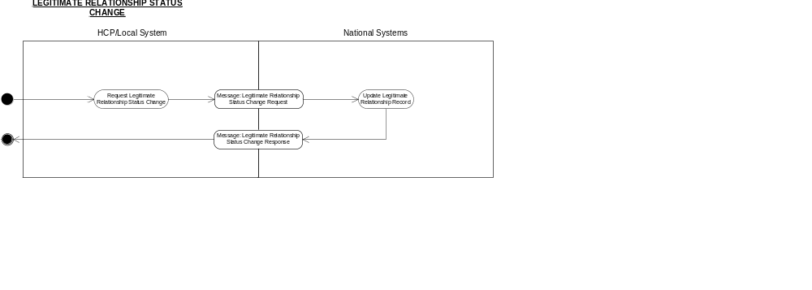

Business Transactions
- Legitimate Relationship Status Change Request
- Legitimate Relationship Status Change Response

Legitimate Relationship Status Change Request

Purpose
The message is generated to notify the national system to update the Legitimate Relationship record between a single patient and a nominated User Role Profile (NCRS User) or Workgroup or Other Person because an event has occurred that the affects the status of the relationship.

Business Communication Requirement

Communication Name | Legitimate Relationship Status Change Request
Sending Role | Request Legitimate Relationship Status Change
Trigger Event | Legitimate Relationship Status Change Required
Communication Type | Request
Receiving Role | Update Legitimate Relationship Record

Business Communication Content

Level | Name  Item/Group | Definition | Example | Representation | Cardinality | Constraints & Dependencies | Default value | Null required | Outstanding issues
1 | Request Identifier | The unique identifier for the message, generated by the system. |  | Format defined by Technical team  UUID | 1..1
2 | Patient Identifier | The unique identifier for the patient involved in the Legitimate Relationship.  The identifier may be a temporary NHS Number, which would later be reconciled with the real NHS Number. | 1234567899 | NHS Number - Data Dictionary Standard  N10, including check digit calculated to Modulus 11 algorithm | 1..1
3 | Legitimate Relationship Identifier | The unique identifier of a specific Legitimate Relationship record to have status changed. | 12345 | OID: 2.16.840.1.113883.2.1.3.2.4.12  (LR System) | 1..1 | Must be used to identify the specific Legitimate Relationship to have status changed context.
5 | Status Change Reason Code | A code indicating the reason for the change of status of the Legitimate Relationship. | 01 denotes Relationship termination | Coded vocab | 1 | Reason codes set according to type of LR:  “Relationship termination”  “Closure of case”  “Referral acceptance”  “Referral rejection”  “Referral abandonment”  “Referral Discharge”  “Patient Registration”  “Patient Deregistration”  “Self-referral cessation”  “Closure of SAR”. See table in Legitimate Relationships Requirements Report to identify which reason code is valid for each LR Type.
8 | Status Change Requester Details |  |  |  | 1..1
 | CHOICE OF
8.1 | Originating User Identifier | The unique identifier for the user requesting the change in status of the Legitimate Relationship.  Required for audit and accountability purposes.  The user generating the request to change the status of the relationship may or may not be the same person as the user involved in the relationship. | 123456789012 | Twelve character UID as defined by the SDS group | 0..1 | Present whenever the change in status of the LR is as a direct result of User action.
8.2 | Originating User Role Profile | The unique identifier for the current Role Profile of the user requesting the change in status of the Legitimate Relationship.  The user generating the request to change the status of the relationship may or may not be the same person as the user involved in the relationship. | 210987654321 | Twelve character UID as defined by the SDS group | 0..1 | Used when the application creating the message wishes to defer to the recipient (the Legitimate Relationship Service) the access control decision on whether the status change is to be authorised. |  |  | This field is not expected to be present in normal use of this message.
 | OR
8.3 | Originating system id | The id of the system that generated the request for status change of LR  The definition of System-Id for this purpose is: “An individual application running upon a server. Where there are multiple (n) applications running upon a single server, then there shall be considered to be n systems”. |  | SDS id | 0..1 | Present when the message is issued automatically by the application as a result of a business process.

Legitimate Relationship Status Change Response

Purpose
The message is generated to inform the user requesting the change in status of the Legitimate Relationship of the outcome of the request.

Business Communication Requirement

Communication Name | Legitimate Relationship Status Change Response
Sending Role | Update Legitimate Relationship Record
Trigger Event | Legitimate Relationship record updated to reflect change of status
Communication Type | Response
Receiving Role | N/A

Business Communication Content

Level | Name  Item/Group | Definition | Example | Representation | Cardinality | Constraints & Dependencies | Default value | Null required | Outstanding issues
1 | Requesting Message Identifier | The identifier for the message requesting the change in status of the Legitimate Relationship.  Required to link the response with the status change message it is responding to. |  | Format defined by Technical team  UUID format | 1
2 | Legitimate Relationship Identifier | The unique identifier of the Legitimate Relationship(s) whose status has changed | 12345 | OID: 2.16.840.1.113883.2.1.3.2.4.12  (LR System) | 1..1 | Contains only one value where the Legitimate Relationship Status Change Request identified a specific LR Record  The message will contain either one or more Legitimate Relationship Identifiers or a Failure Reason Code, but not both.
3 | Failure Reason Code | A code denoting the reason for failure to change the status of the Legitimate Relationships identified in the Legitimate Relationship Status Change Request message. | 01 denotes User Role Profile not found | User Role Profile not found  LR ID not found  WorkGroup ID not found  NHS Number not found  No LR found with a status compatible with this status change request (returned when no specific LR id was nominated in the change request), or the LR with the nominated LR ID has a status and type incompatible with this status change request. | 0..1 | Will not be included if one or more Legitimate Relationship Identifier values are present.  The message will contain either one or more Legitimate Relationship Identifiers or a Failure Reason Code, but not both. |  |  | Minimum code value set subject to change.  The single code so far specified for the incom-patibility failures may be split into a number of more specific codes.
Note : Failure Reason Code modelled in a separate message.

Legitimate Relationship Confirmation Request

Description
Confirmation Requests on Legitimate Relationships are intended to determine whether or not a relationship exists between a patient and an individual User Role Profile (NCRS User) or Other Person. The user (or local system) or application requests the confirmation, including whether a ‘short’ or ‘history’ response is required. The national system obtains the relevant details from the Legitimate Relationship database, and returns an appropriate response to the user (or local system). It is expected that this activity will occur frequently, as a pre-cursor to subsequent action concerning Legitimate Relationship record management or patient record access activities.

Clinical Scenario
To be determined, pending design of the end-to-end business processes.

Activity diagram
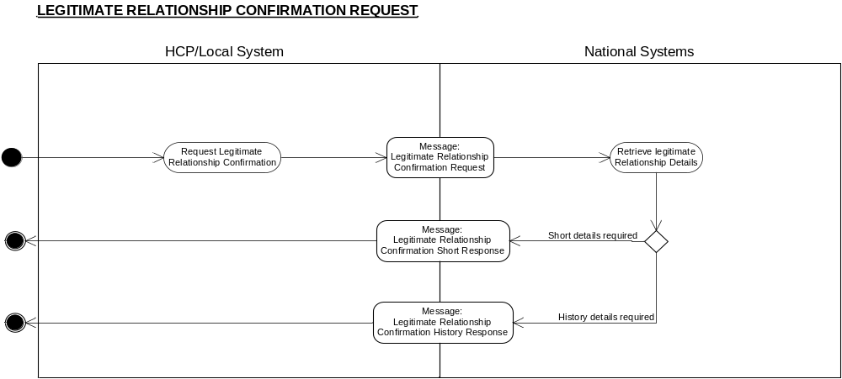

Business Transactions
- Legitimate Relationship Confirmation Request
- Legitimate Relationship Confirmation Short Response
- Legitimate Relationship Confirmation History Response

Legitimate Relationship Confirmation Request

Purpose
The message is to request the relevant national system to ascertain whether or not a Legitimate Relationship between an entity (User acting in a particular Role Profile or other person) and a single patient exists, or has existed.

Work continues to define the design for how historic requests for LR confirmations will be dealt with, but no significant changes are expected. However it is not expected that it will affect the manner in which requests for current LRs are constructed.

Business Communication Requirement

Communication Name | Legitimate Relationship Confirmation Request
Sending Role | Request Legitimate Relationship Confirmation
Trigger Event | Confirmation of the existence of Legitimate Relationship is required
Communication Type | Request
Receiving Role | Retrieve Legitimate Relationship Details

Business Communication Content

Level | Name  Item/Group | Definition | Example | Representation | Cardinality | Constraints & Dependencies | Default value | Null required | Outstanding issues
1 | Request Identifier | The unique identifier for the request message, generated by the system. |  | Format defined by Technical team  UUID format | 1
2 | Patient Identifier | The unique identifier for the patient whose involvement in an LR with the identified User or Other Person is being confirmed. | 1234567899 | NHS Number - Data Dictionary Standard  N10, including check digit calculated to Modulus 11 algorithm | 1..1
3 | Start User group |  |  |  | 0..1 | The query is either in relation to a User or to a person with an NHS number, but not both.
3.1 | User Id | The Id of the User for whom the relationship is being confirmed | 123456789012 | Twelve character UID as defined by the SDS group | 1
3.2 | User Role Profile | The Role Profile for which the User whose relationship with the patient is being confirmed. | 210987654321 | Twelve character UID as defined by the SDS group | 1
3.3 | Work group code | List of workgroup codes found in user’s current role profile, one per occurrence of this field | RMH00055 | SDS allocated | 0..n
 | End User Group
4 | Start other Person Group
4.1 | Other Person NHS Number | The unique identifier for the Other Person possibly involved in a Legitimate Relationship with the patient. | 1234567899 | NHS Number Data Dictionary standard  N10, including check digit calculated to Modulus 11 algorithm | 0..1 | Not to be returned in P1R2 |  |  | Added as placeholder for possible future implementation.
 | End Other Person Group
5 | Required Enquiry Response Type | A code to indicate the type of response required.  Required to prevent unnecessary and expensive computational searches of historic data. | Short | 5 character alphanumeric | 1 | ‘Short’;  or ‘Hist ”. Where “Short” is entered, only “active” relationships will be identified. Where “Hist” is entered, both active and “frozen” relationships will be identified. | ‘Short’
6 | Start User originated request information Group |  |  |  | 0..1 | Present whenever the confirmation is as a direct result of a User query rather than system initiated. |  |  | It is not expected that this subgroup will be in normal use of the message.
6.1 | Originating User Identifier | The unique identifier for the user requesting the confirmation.  Required for audit and accountability purposes.  The User generating the confirmation request may or may not be the same person as the User involved in the relationship. | 123456789012 | Twelve character UID as defined by the SDS group | 1
6.2 | Originating User Role Profile | The unique identifier for the current Role Profile of the user requesting the confirmation.  The user generating the request for confirmation may or may not be the same person as the user involved in the relationship. | 210987654321 | Twelve character UID as defined by the SDS group | 0..1 | Used when the application creating the message wishes to defer to the recipient (the Legitimate Relationship Service) the access control decision on whether the confirmation is to be authorised. Not used when the confirmation query is system initiated
 | OR
6.3 | Originating system id | The id of the sytem that generated the query  The definition of System-ID for this purpose is: “An individual application running upon a server. Where there are multiple (n) applications running upon a single server, then there shall be considered to be n systems” |  | SDS id | 0..1 | Present when the message is issued automatically by the application as a result of a business process.
 | End User originated request information Group

Legitimate Relationship Confirmation Short Response

Purpose
The message contains details which indicate the existence (or otherwise) of a current (active) Legitimate Relationship between a patient and a User or other person.

Business Communication Requirement

Communication Name | Legitimate Relationship Confirmation Short Response
Sending Role | Retrieve Legitimate Relationship Details
Trigger Event | Legitimate Relationship Confirmation Request received
Communication Type | Response
Receiving Role | N/A

Business Communication Content

Level | Name  Item/Group | Definition | Example | Representation | Cardinality | Constraints & Dependencies | Default value | Null required | Outstanding issues
1 | Originating Request Identifier | The unique identifier for the originating request message.  Required to link the Request with the Response. |  | Format defined by Technical team  UUID Format | 1
2 | Start Response Subgroup | Response or failure for the patient for which a confirmation request was made |  |  | 1
2.1 | Legitimate Relationship Existence Indicator | A value stating the existence or absence of a Legitimate Relationship record | “Yes” | Boolean | 0..1 | “Yes”; “No”  Either this Boolean appears or a failure reason code appears but not both.
2.2 | Failure Reason Code | A code indicating a failure to locate a legitimate relationship record due to inaccuracy of requesting data or other system problem. | 01 denotes User Role Profile not found | Patient not found.  User Id Not Found.  User Role Profile not found  LR ID not found  Other User NHS Number not found | 0..1 | Will only be included where a failure to locate a Legitimate Relationship record is due to an inability to locate a Legitimate Relationship party specified in the request, and thus no Boolean value can be offered. |  |  | Minimum code value set may be subject to change.
 | End Response Group
Note : Failure Reason Code modelled in a separate message.

Legitimate Relationship Confirmation History Response

Purpose
The message contains details which indicate the existence (or otherwise) of Legitimate Relationships between a patient and a User or other person, and, where appropriate, the freeze date and time of the relationship record.

Business Communication Requirement

Communication Name | Legitimate Relationship Confirmation History Response
Sending Role | Retrieve Legitimate Relationship Details
Trigger Event | Legitimate Relationship Confirmation Request received.
Communication Type | Response
Receiving Role | N/A

Business Communication Content

Level | Name  Item/Group | Definition | Example | Representation | Cardinality | Constraints & Dependencies | Default value | Null required | Outstanding issues
1 | Originating Request Identifier | The unique identifier for the originating request message.  Required to link the Request with the Response. |  | Format defined by Technical team  UUID Format | 1
2 | Start Response Subgroup | Response or failure. |  |  | 1
2.1 | Legitimate Relationship Existence Indicator | A value stating the existence or absence of a Legitimate Relationship record | “Yes” | Boolean | 0..1 | “Yes”; “No”  Either this Boolean appears or a failure reason code appears but not both.
2.2 | Historic Legitimate Relationship End Date and Time | The date and time at which the latest historic Legitimate Relationship valid for the User Role Profile or other user specified in the request was Frozen. | 20041231235959 | HL7 standard, accurate to ‘seconds’ | 0..1 | Not present if there is a current LR satisfying the criteria of if a failure code is present.
2.3 | Failure Reason Code | A code indicating a failure to locate a legitimate relationship record due to inaccuracy of requesting data or other system problem. | 01 denotes User Role Profile not found | Patient not found.  User Id Not Found.  User Role Profile not found  LR ID not found  Other User NHS Number not found | 0..1 | Will only be included where a failure to locate a Legitimate Relationship record is due to an inability to locate a Legitimate Relationship party specified in the request, and thus no Boolean value can be offered. |  |  | Minimum code value set may be subject to change.
 | End Response Group
Note : Failure Reason Code modelled in a separate message.

Legitimate Relationship Batch Confirmation Request
PLEASE NOTE: BATCH MESSAGES ARE NOT INCLUDED IN MIM 3.1.07

Description
Batch Confirmation Requests on Legitimate Relationships are intended to determine whether or not an active Legitimate Relationship exists between a list of patients and an individual User Role Profile (NCRS User) or Other Person. The user (or local system) or application requests the confirmation. With batch requests no historic response is available. The national system obtains the relevant details from the Legitimate Relationship database, and returns an appropriate response to the user (or local system). It is expected that batch requests will occur as a pre-cursor to subsequent action concerning accesses to patient lists in a variety of business contexts.

Clinical Scenario
To be determined, pending design of the end-to-end business processes.

Activity diagram

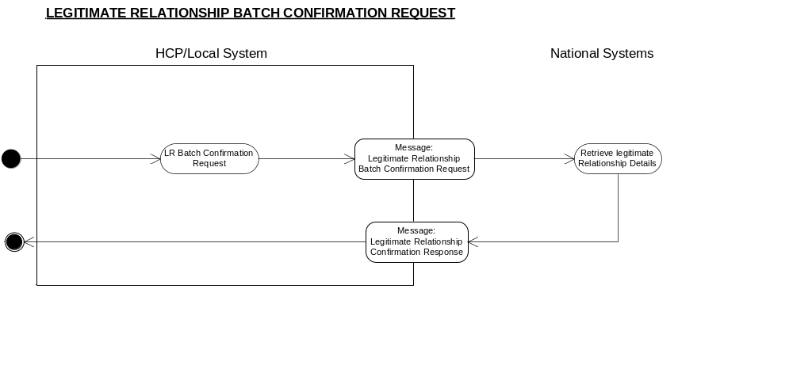

Business Transactions
- Legitimate Relationship Confirmation Request
- Legitimate Relationship Confirmation Short Response
- Legitimate Relationship Confirmation History Response

Legitimate Relationship Batch Confirmation Request

Purpose
The message is to request the relevant national system to ascertain whether or not an active Legitimate Relationship between an entity (User acting in a particular Role Profile or other person) and a list of patient exists.

Business Communication Requirement

Communication Name | Legitimate Relationship Batch Confirmation Request
Sending Role | Request Legitimate Relationship Confirmation
Trigger Event | Confirmation of the existence of more than one Legitimate Relationship is required
Communication Type | Request
Receiving Role | Retrieve Legitimate Relationship Details

Business Communication Content

Level | Name  Item/Group | Definition | Example | Representation | Cardinality | Constraints & Dependencies | Default value | Null required | Outstanding issues
1 | Request Identifier | The unique identifier for the request message, generated by the system. |  | Format defined by Technical team  UUID format | 1
2 | Patient Identifiers | The unique identifiers for the patient whose involvement in an LR with the identified User or Other Person is being confirmed. | 1234567899 | NHS Number - Data Dictionary Standard  N10, including check digit calculated to Modulus 11 algorithm | 2..*
3 | Start User group |  |  |  | 0..1 | The query is either in relation to a User or to a person with an NHS number, but not both.
3.1 | User Id | The Id of the User for whom the relationship is being confirmed | 123456789012 | Twelve character UID as defined by the SDS group | 1
3.2 | User Role Profile | The Role Profile for which the User whose relationship with the patient is being confirmed. | 210987654321 | Twelve character UID as defined by the SDS group | 1
3.3 | Work group codes | List of workgroup codes found in user’s current role profile, one per occurrence of this field | RMH00055 | SDS allocated | 0..n
 | End User Group
4 | Start other Person Group
4.1 | Other Person NHS Number | The unique identifier for the Other Person possibly involved in a Legitimate Relationship with the patient. | 1234567899 | NHS Number Data Dictionary standard  N10, including check digit calculated to Modulus 11 algorithm | 0..1 | Not to be returned in P1R2. |  |  | Added as placeholder for possible future implementation.
 | End Other Person Group
6 | Start User originated request information Group |  |  |  | 0..1 | Present whenever the confirmation is as a direct result of a User query rather than system initiated.
6.1 | Originating User Identifier | The unique identifier for the user requesting the confirmation.  Required for audit and accountability purposes.  The User generating the confirmation request may or may not be the same person as the User involved in the relationship. | 123456789012 | Twelve character UID as defined by the SDS group | 1
6.2 | Originating User Role Profile | The unique identifier for the current Role Profile of the user requesting the confirmation.  The user generating the request for confirmation may or may not be the same person as the user involved in the relationship. | 210987654321 | Twelve character UID as defined by the SDS group | 0..1 | Used when the application creating the message wishes to defer to the recipient (the Legitimate Relationship Service) the access control decision on whether the confirmation is to be authorised. Not used when the confirmation query is system initiated
 | OR
6.3 | Originating system id | The id of the system that initiated the query  The definition of System-Id for this purpose is: “An individual application running upon a server. Where there are multiple (n) applications running upon a single server, then there shall be considered to be n systems.” |  | SDS id | 0..1 | Present when the message is issued automatically by the application as a result of a business process.
 | End User originated request information Group

Legitimate Relationship Batch Confirmation Response

Purpose
The message contains details which indicates, for each patient in the request, the existence (or otherwise) of a current (active) Legitimate Relationship between that patient and a User or other person.

Business Communication Requirement

Communication Name | Legitimate Relationship Batch Confirmation Response
Sending Role | Retrieve Legitimate Relationship Details
Trigger Event | Legitimate Relationship Batch Confirmation Request received
Communication Type | Response
Receiving Role | N/A

1 | Originating Request Identifier | The unique identifier for the originating request message.  Required to link the Request with the Response. |  | Format defined by Technical team  UUID Format | 1
2 | Start Response Subgroup | Response or failure for each patient for which a confirmation request was made |  |  | 0..* | Not present only if an overall failure has occurred (see field 3). Values in the group are repeated of the same number and in the same sequence as the patients are listed in the request.
2.1 | Patient Identifier | The unique identifier for the patient whose involvement in an LR with the identified User or Other Person is being confirmed. | 1234567899 | NHS Number – Data Dictionary Standard  N10, including check digit calculated to Modulus 11 algorithm | 1
2.2 | Legitimate Relationship Existence Indicator | A value stating the existence or absence of a Legitimate Relationship record | “Yes” | Boolean | 0..1 | “Yes”; “No”  Either this Boolean appears or a failure reason code appears but not both.  The Boolean must be paired with the NHS number of the patient to whom the request applied.
2.3 | Failure Reason Code | A code indicating a failure to locate a legitimate relationship record due to inaccuracy of requesting data or other system problem. | 01 denotes User Role Profile not found | Patient not found.  User Id Not Found.  User Role Profile not found  LR ID not found  Other User NHS Number not found | 0..1 | Will only be included in relation to a particular patient where a failure to locate a Legitimate Relationship record is due to an inability to locate a Legitimate Relationship party specified in the request, and thus no Boolean value can be offered. |  |  | Minimum code value set may be subject to change.
 | End Response Group
3 | Overall Failure Reason Code | A code indicating an overall failure to provide the requested responses due to inaccuracy of requesting data or other system problem. |  |  | 0..1 | Either this field or the Response Subgroup field will be present

Obtain Legitimate Relationship Details

Description

The process identifies the Legitimate Relationships that exist between a patient and an individual User (NCRS User), Workgroup or Other Person and retrieves the pertinent details from the database record. The user (or local system) or application submits the request, including whether a ‘simple’ or ‘complete’ response is required. The NASP service obtains the relevant details, and returns an appropriate response to the user (or local system).

This message will be generally used in response to administrative actions required against the Legitimate Relationship record, for management purposes. As this message can return an LR id code, it can be used when there is a requirement to update an LR and the LR id is not persisted on the local system.

Clinical Scenario
To be determined, pending design of the end-to-end business processes.

Activity diagram
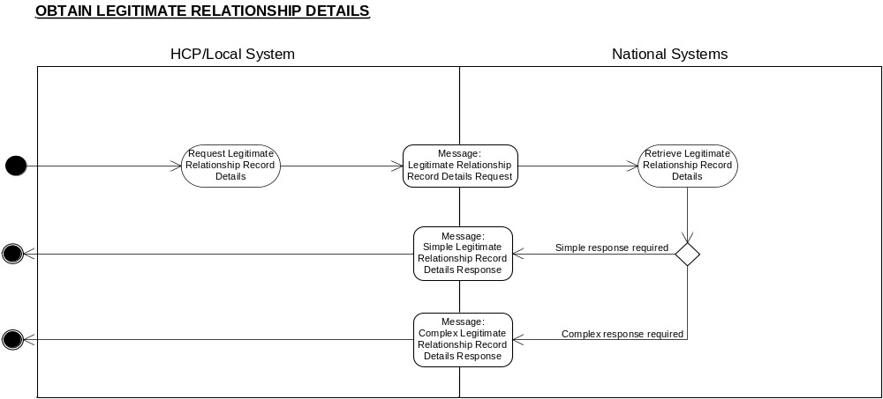

Business Transactions
- Legitimate Relationship Record Details Request
- Simple Legitimate Relationship Record Details Response
- Complete Legitimate Relationship Record Details Response

Legitimate Relationship Record Details Request

Purpose
The message notifies the national system of a request to retrieve and return the contents of all relevant Legitimate Relationship records held for the patient , in order to determine which individuals or workgroups are or were involved in a Legitimate Relationship with the specified patient for a (optional) specified time period. There is a capability to specify the amount of information returned.

Business Communication Requirement

Communication Name | Legitimate Relationship Record Details Request
Sending Role | Legitimate Relationship Record Details
Trigger Event | Legitimate Relationship Record details required
Communication Type | Request
Receiving Role | Retrieve Legitimate Relationship Record Details

Business Communication Content

 | Level | Name  Item/Group | Definition | Example | Representation | Cardinality | Constraints & Dependencies | Default value | Null required | Outstanding issues
 | 1 | Request Identifier | The unique identifier for the request, generated by the system. |  | Format defined by Technical team | 1
 | 2 | Patient Identifier | The unique identifier for the patient involved in the Legitimate Relationship. | 1234567899 | NHS Number - Data Dictionary Standard  N10, including check digit calculated to Modulus 11 algorithm | 1
 | 3 | Required Enquiry Response Type | A code to indicate the type of response required | “Comp” | Coded vocab  01 Simple  02 Comprehensive | 1 | ‘A ‘simple’ query requires minimal information to be in the response, i.e. for each relationship detected, the users/ workgroups involved in the relationship, and any freeze date within the time period specified that has been set for the relationship.
 | 4 | Time Period | The period of time to which the query pertains. | 01/01/2003  to 01/01/2004  HHMMSS | Date/Time Interval. | 0..1 | If no Time Period is specified, only current active relationships will be returned in the response.  Cannot have a high sub-element without a low but a low sub-element can exist without a high sub-element. | No default for Start Date.  Default for ‘End Date’ (or equivalent) is Current Date
 | 5 | Originating User Identifier | The unique identifier for the user requesting the Legitimate Relationship details.  Required for audit and accountability purposes. | 123456789012 | Twelve character UID as defined by the SDS group | 1
6 |  | Override Dissent Flag | Boolean Flag through which the caller requests that patient dissent should be overridden. |  | Boolean | 1..1 | Values:  1 = Override  0 = No override  Omitting this field is the equivalent of setting its value to 0.  Must only be set to 1 if the user has been warned that the patient has dissented and has confirmed that despite this they wish to override dissent.
7 |  | Override Dissent Reason Code | A code indicating the reason for the override, provided for insertion in the alert that must be raised by the NASP as a consequence of overriding dissent. |  |  | 1..1 | Values are:  00 = No override  01 = Public Interest  02 = Required by Statute  03 = Court Order  04 = Best interest of patient who lacks mental capacity to give consent  05 = Best interest of non-competent child when parent or guardian has refused consent & insufficient time to obtain court order.
8 |  | Override Dissent Reason Text | Further explanation of the reason for override, provided for insertion in the alert that must be raised by the NASP as a consequence of overriding dissent. |  | No existing equivalent in the Data Dictionary. Format for similar free-text fields is AN255 | 0..1 | Free text present when available. (ie whenever entered by the user).
 | 9 | Originating User Role Profile | The unique identifier for the current Role Profile of the user making the request. | 210987654321 | Twelve character UID as defined by the SDS group | 0..1 | Used when the application creating the message wishes to defer to the recipient (the Legitimate Relationship Service) the access control decision on whether the request is to be authorised.

Simple Legitimate Relationship Record Details Response

Purpose
The message contains basic details for Legitimate Relationship records held satisfying the criteria laid down in the originating request, showing the individuals and/or workgroups involved in Legitimate Relationships with the specified patient.

Business Communication Requirement

Communication Name | Simple Legitimate Relationship Record Details Response
Sending Role | Retrieve Legitimate Relationship Record Details
Trigger Event | Legitimate Relationship Record Details Request received
Communication Type | Response
Receiving Role | N/A

Business Communication Content

Level | Name  Item/Group | Definition | Example | Representation | Cardinality | Constraints & Dependencies | Default value | Null required | Outstanding issues
1 | Originating Request Identifier | The unique identifier for the originating request message.  Required to link the Request with the Response. |  | Format defined by Technical team  UUID Format | 1
2 | Patient Identifier | The unique identifier for the patient involved in the Legitimate Relationship(s). | 1234567899 | NHS Number - Data Dictionary Standard  N10, including check digit calculated to Modulus 11 algorithm | 1
3 | Start Legitimate Relationships Details Group |  |  |  | 0..* | A cardinality of zero is possible because there may be no LRs satisfying the request criteria or there may have been a failure.
3.1 | Legitimate Relationship Identifier | The unique identifier of the Legitimate Relationship record created on the national system. | 12345 | OID: 2.16.840.1.113883.2.1.3.2.4.3
3.2 | Start Legitimate Relationship Parties sub-group |  |  |  | 1 | This group will contain either a User Identifier, Workgroup Details or Other Person Subgroup.
3.2.1 | Start Workgroup Details Subgroup |  |  |  | 0..1 | Each entry is either a Work group Identifier, a User/Profile identifier or an Other Person Identifier
3.2.1.1 | Workgroup Identifier | An identifier for a Workgroup. | RMH00055 | SDS allocated | 1
 | End Workgroup Details Subgroup
3.2.2 | Start User Details Subgroup |  |  |  | 0..1 | Each entry is either a Work group Identifier, a User identifier with User Role Profile or an Other Person Identifier
3.2.2.1 | User Identifier | The unique identifier for a User (e.g. the Health Care Professional, Administrator, Technician, etc.) involved in the Legitimate Relationship. | 123456789012 | Twelve character UID as defined by the SDS group | 1
3.2.2.2 | User Role Profile | The context in which the individual acts as part of the Legitimate Relationship. | 210987654321 | Twelve character UID as defined by the SDS group | 1 | User Identifier must exist
 | End User Details Subgroup
3.2.3 | Start Other Person details subgroup |  |  |  | 0..1 | Each entry is either a Work group Identifier, a User/Profile identifier or an Other Person Identifier
3.2.3.1 | Other Person NHS Number | The unique identifier for the Other Person involved in the Legitimate Relationship. | 1234567899 | NHS Number Data Dictionary standard  N10, including check digit calculated to Modulus 11 algorithm | 1 | Not to be returned in P1R2 |  |  | Included as a placeholder for future use
 | End other Person details subgroup
 | End Legitimate Relationship Parties Sub-group
3.3 | Legitimate Relationship Freeze Date and Time | The date and time at which the Legitimate Relationship was Frozen. | 20041231235959 | HL7 standard, accurate to ‘seconds’ | 0..1 | The presence of this date is also used to indicate that the status of the Legitimate Relationship is frozen. (expired relationships are not returned at all).
 | End Legitimate Relationship Details Group
4 | Failure Reason Code | A code denoting the reason for failure to perform the requested action. | 01 denotes  User Role Profile not found | Patient not found  Originating User Role Profile not found | 0..1 | Will not be included if a Legitimate Relationships Subgroup value is present.  The message will contain either one or more Legitimate Relationships subgroups or a Failure Reason Code, but not both. |  |  | Minimum code value set may be subject to change.
Note: Failure Reason Code modelled in a separate message.

Complete Legitimate Relationship Record Details Response

Purpose
The message contains the full details for Legitimate Relationship records held on the database satisfying the criteria laid down in the originating request, showing the individuals or workgroups involved in Legitimate Relationships with the specified patient.

Business Communication Requirement

Communication Name | Complete Legitimate Relationship Record Details Response
Sending Role | Retrieve Legitimate Relationship Record Details
Trigger Event | Legitimate Relationship Record Details Request received
Communication Type | Response
Receiving Role | N/A

Business Communication Content

Level | Name  Item/Group | Definition | Example | Representation | Cardinality | Constraints & Dependencies | Default value | Null required | Outstanding issues
1 | Originating Request Identifier | The unique identifier for the originating request message.  Required to link the Request with the Response. |  | Format defined by Technical team  UUID Format | 1
2 | Patient Identifier | The unique identifier for the patient involved in the Legitimate Relationship(s). | 1234567899 | NHS Number - Data Dictionary Standard  N10, including check digit calculated to Modulus 11 algorithm | 1
3 | Start Legitimate Relationship Details Group |  |  |  | 0..* | A cardinality of zero is possible because there may be no LRs satisfying the request criteria or there may have been a failure.
3.1 | Legitimate Relationship Identifier | The unique identifier of the Legitimate Relationship record created on the national system. | 12345 | OID: 2.16.840.1.113883.2.1.3.2.4.3  (LR System) | 1
3.2 | Start Legitimate Relationship Parties Sub-group |  |  |  | 1 | Each entry is either a Work group Identifier, a User/Profile identifier or an Other Person Identifier
3.2.1 | Start Workgroup Details Subgroup |  |  |  | 0..1 | This group will contain either a User Identifier, Workgroup Details or Other Person Subgroup.
3.2.1.2 | Workgroup Identifier | An identifier for a Workgroup. | RMH00055 | SDS allocated | 1
 | End Workgroup Details Subgroup
3.2.2 | Start user details subgroup |  |  |  | 0..1 | Each entry is either a Work group Identifier, a User identifier with User Role Profile or an Other Person Identifier
3.2.2.1 | User Identifier | The unique identifier for a User (e.g. the Health Care Professional, Administrator, Technician, etc.) involved in the Legitimate Relationship. | 123456789012 | Twelve character UID as defined by the SDS group | 1 | The message will contain either a User Identifier, a Workgroup Details or Other Person Subgroup, but not all three.
3.2.2.2 | User Role Profile | The context in which the individual acts as part of the Legitimate Relationship. | 210987654321 | Twelve character UID as defined by the SDS group | 1
 | End user details subgroup
3.2.3 | Start Other person details subgroup |  |  |  | 0..1 | Each entry is either a Work group Identifier, a User identifier with User Role Profile or an Other Person Identifier
3.2.3.1 | Other Person NHS Number | The unique identifier for the Other Person involved in the Legitimate Relationship. | 1234567899 | NHS Number Data Dictionary standard  N10, including check digit calculated to Modulus 11 algorithm | 1 | Not to be returned in P1R2. |  |  | Included as a placeholder for future use.
 | End Other Person details subgroup
 | End Legitimate Relationship Parties Sub-group
3.3 | Legitimate Relationship Start Date and Time | The date and time from which the Legitimate Relationship is active. | 20041231235959 | HL7 standard, accurate to ‘seconds’ | 1
3.4 | Legitimate Relationship Freeze Date and Time | The date and time at which the Legitimate Relationship was Frozen. | 20041231235959 | HL7 standard, accurate to ‘seconds’ | 0..1 | The presence of this date is also used to indicate that the status of the Legitimate Relationship is frozen. (expired relationships are not returned at all).
3.5 | Legitimate Relationship Type | A pre-defined code indicating the type of Legitimate Relationship. | 01 denotes ACREQ | Coded vocab | 1..1 | Minimum value set:  ACREQ  CMPLN  GRANT  EXPRS  ORDER  REFER  REG  SLFCL  PSRFR  NB backward compatible with 2.2
3.6 | Legitimate Relationship Reason for Access | Where the Legitimate Relationship Type is “EXPRS”, “SLFCL” or “GRANT”, a standard reason for the access must exist. |  |  | 0..1 | See Legitimate Relationship Requirements Report for the list of standard values.
3.7 | Legitimate Relationship Reason Text | A free-text element to record the reason for the Legitimate Relationship to exist. |  | No existing equivalent in the Data Dictionary. Format for similar free-text fields is AN255 | 0..1 | Free-text may be present for any Legitimate Relationship Reason Code  This field will be present if Reason for Access is OTHER.
3.8 | Legitimate Relationship Creator Identifier | The unique identifier for the user requesting the creation of the Legitimate Relationship. | 987654321 | OID: 2.16.840.1.113883.2.1.3.2.4.11  (NHS Directory Services) | 0..1 | Will not always be present – creator may not always be known.
3.9 | Legitimate Relationship Creator Role Profile | The context in which the creator of the Legitimate Relationship was acting when requesting the creation of the relationship | 31234 |  | 0..1 | May not always be known.  The Creator Identifier must also be present if this field is present.
 | OR
3.10 | LR Creator system id | The id of the system that created the LR  The definition of System-id for this purpose is: “An individual application running upon a server. Where there are multiple (n) applications running upon a single server, then there shall be considered to be n systems |  | SDS id | 0..1 | This will be present to indicate those LRs which were not user generated.
3.11 | Status Change Reason Code | A code indicating the reason for the freezing of the Legitimate Relationship. | 02 denotes WORKGROUP CLOSURE | Coded vocab list | 0..1 | NB backward compatible with 2.2
3.12 | Legitimate Relationship Status Changer Identifier | The unique identifier for the user requesting the freezing of the Legitimate Relationship. |  | UID or UUID | 0..1 | Will not always be present – freeze may be automatic. |  |  | It may be the case that freeze setting is always automatic, in which case this field will never appear.
3.13 | Legitimate Relationship Status Changer Role Profile | The context in which the freezer of the Legitimate Relationship was acting when requesting the freezing of the relationship | 31234 | OID: 2.16.840.1.113883.2.1.3.2.4.11  (NHS Directory Services) | 0..1 | May not always be known – freeze may be automatic.  The Creator Identifier must also be present if this field is present.
 | End Legitimate Relationship Details Group
4 | Failure Reason Code | A code denoting the reason for failure to perform the requested action. | 01 denotes  User Role Profile not found | Patient not found  Originating User Role Profile not found | 0..1 | Will not be included if a Legitimate Relationship Parties Subgroup value is present.  The message will contain either one or more Legitimate Relationship Parties subgroups or a Failure Reason Code, but not both. |  |  | Minimum code value set may be subject to change.
Note : Failure Reason Code modelled in a separate message.

This is being catered for within the message to allow for the possible future requirement that the NASP service will maintain, and act upon, legitimate relationships between patients and third party proxies for a patient (e.g. a relative or carer), however this is NOT supported for P1R2.

